City of Prince Albert
Saskatchewan, Canada

Proclamation

WHEREAS the City’s Procedure Bylaw No. 23 of 2021 authorizes the Mayor to approve proclamations.

LET IT BE KNOWN THAT I, Mayor Bill Powalinsky, do hereby proclaim the
Month of May, 2025 in the City of Prince Albert as:

Melanoma and Skin Cancer Awareness Month

Dated this 9th day of April, 2025.


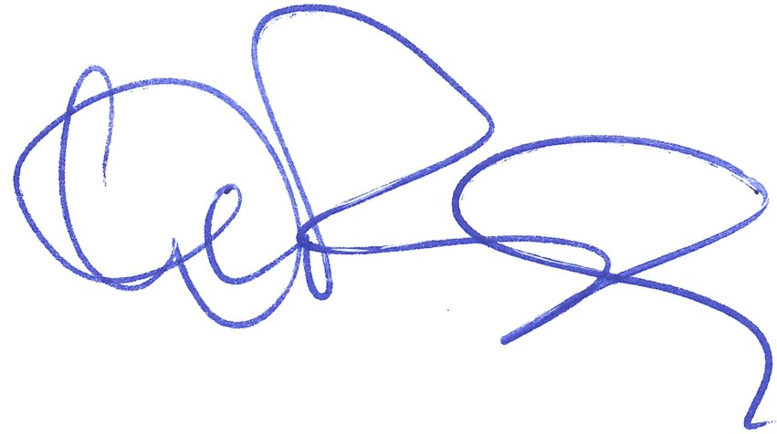

Bill Powalinsky
Mayor

